Examination of the Lumbar Spine

If the patient complains of leg symptoms refer to the dermatome section to give a reasonable assumption at which level the lesion is, i.e. lateral calf numbness/P+N/pain=L5 nerve root. (However remember a high lesion can affect lower nerve roots!).

Subjective Examination
The lumbar spine normally gives pain during prolonged sitting, lifting and stooping. Generally pain upon walking tends to originate from the hip, spinal stenosis or circulatory disorders. For objective markers use functional levels to assess improvement i.e., time to dress, sit etc without pain.

Examination undertaken satisfactorily: Yes/No/incomplete

Objective Examination
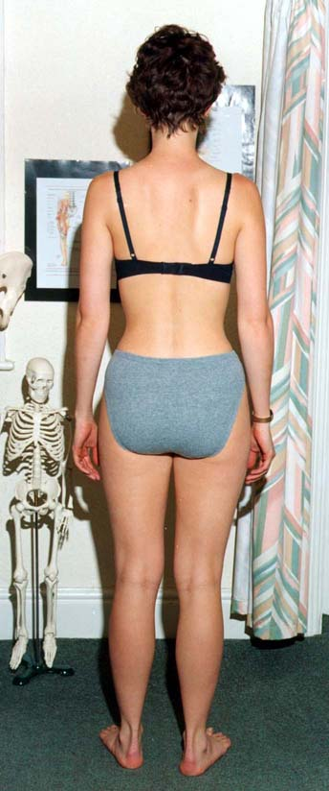
Leg length discrepancies are best judged
in standing – use different sized heel raises/arch
supports to correct inequality.

Examination undertaken satisfactorily: Yes/No/incomplete

Check
Correctable scoliosis, increased thoracic
kyphosis tone/bulk loss and general posture.

Examination undertaken satisfactorily: Yes/No/incomplete

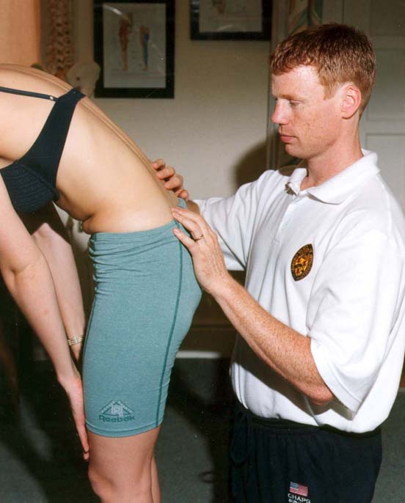

Flexion
Getting the patient to touch their toes will measure hip/neural flexibility not lumbar movement. For a more accurate measurement palpate individual segmental movement.

Examination undertaken satisfactorily: Yes/No/incomplete

Check

Correct pelvic tilting rhythm

Examination undertaken satisfactorily: Yes/No/incomplete


Side Flexion

Measure hand to knee distance

Examination undertaken satisfactorily: Yes/No/incomplete

Check
Quality of each segmental movement

Examination undertaken satisfactorily: Yes/No/incomplete

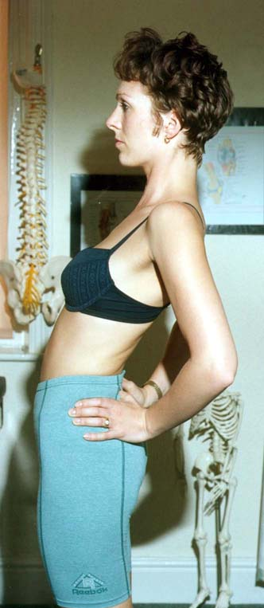
Extension
Often restricted but sometimes relieves symptoms.

Examination undertaken satisfactorily: Yes/No/incomplete

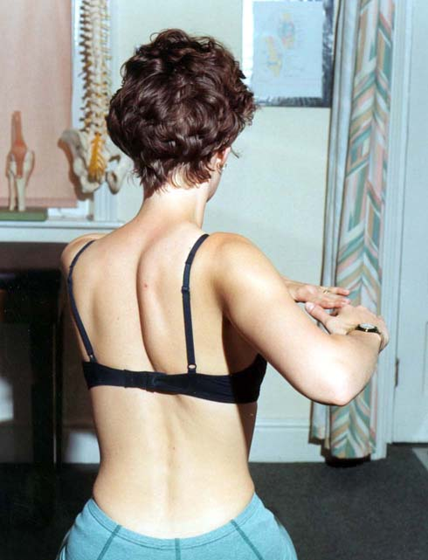

Rotation
Best measured in sitting to eliminate Leg/Hip rotation.

Examination undertaken satisfactorily: Yes/No/incomplete

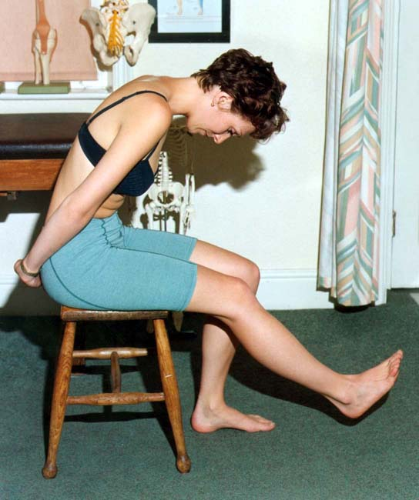
Check
Asymmetry
Examination undertaken satisfactorily: Yes/No/incomplete

Slump Test
This is quite an aggressive test to check neural length. Problems driving are often reproduced.

Examination undertaken satisfactorily: Yes/No/incomplete

Check
Good to affected. Add in ankle dorsiflexion and knee extension slowly. Compare this test to SLR i.e.. If slump test negative but SLR 30 deg positive!!

Examination undertaken satisfactorily: Yes/No/incomplete

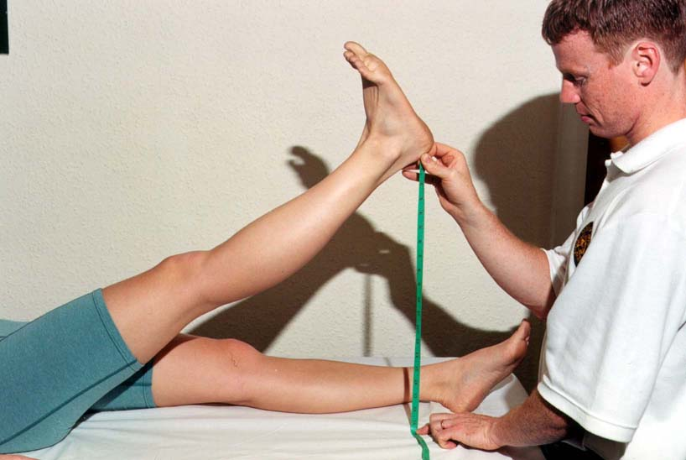
SLR

Measure heel to plinth with knee locked in extension and ankle plantargrade.

Examination undertaken satisfactorily: Yes/No/incomplete

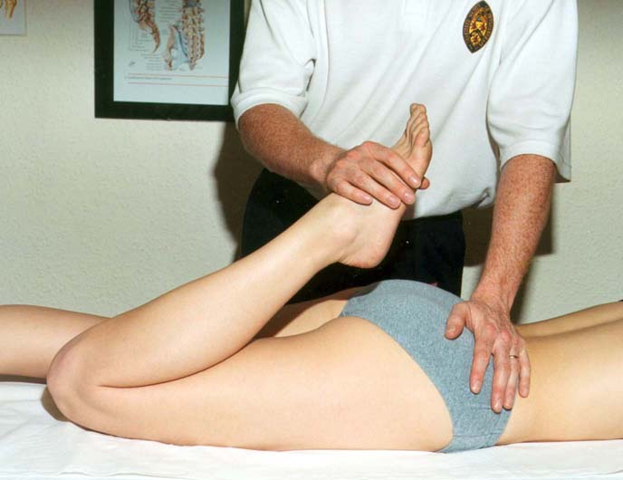
Passive Knee Bend
To check femoral nerve length. Add in foot movements to reproduce the patient’s pain.

Examination undertaken satisfactorily: Yes/No/incomplete

Finally, palpate to pin point the local lesion start lightly

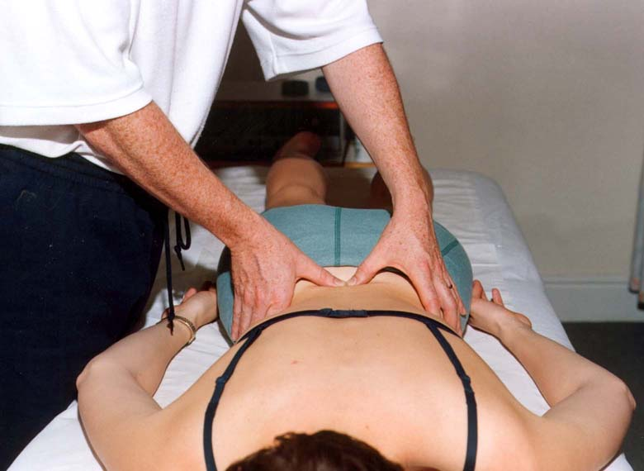
Examination undertaken satisfactorily: Yes/No/incomplete

